INVITATION

We have the honor to invite you to participate to the 7th International Workshop of Electromagnetic Compatibility CEM 2010 organized by the National Institute for Research and Development in Electrical Engineering INCDIE ICPE-CA, Bucharest, Romania.

The aim of the workshop

The workshop will be a good reason for the dissemination and promoting of the Romanian and foreign scientific researches results, knowledge of the newest achievements in the approached thematic domain, the maintaining of direct contact among the specialists, opening, development of the new research directions, identification of the creating possibilities of some consortia with the polarization of the values research forces regarding the approaching of some large projects and participations to the European research programs.

The workshop thematic

It will approach the following aspects:
- electromagnetic compatibility in the domains: electronics, communications systems, industrial systems;
- biocompatibility;
- human exposition effects to the electromagnetic fields;
- electromagnetic nondistructive evaluation;
- standardization issues.

PROGRAM COMMITTEE
Adrian GRAUR – president
Romania
Gilbert DECAT– vice – president
Belgium
Levente BUNTA – vice – president
Romania
Luis Adriano Domingues
Brasil
Florin Teodor TĂNĂSESCU
Romania
Paul Svasta
Romania
Marcel OPRIŞ
Romania
Alexandru SOTIR
Romania
Istvan Borbath
Romania
Gheorghe Samoilescu
Romania
Gyorgy VARJU
Hungary
Emil Simion
Romania
Elena Helerea
Romania
Dan Cristian Rucinschi
Romania
Wilhelm Kappel
Romania
Simona MiclauŞ
Romania

Organizing Committee
Georgeta Alecu
INCDIE ICPE - CA, Bucharest, Romania
Gyorgy FARKAS
Mayoralty of Odorheiu Secuiesc, Romania
Gabriela Obreja
INCDIE ICPE – CA, Bucharest, Romania
Tunde BORBATH
SC ROSEAL SA Odorheiu Secuiesc, Romania
Gimi Aurelian Rimbu
INCDIE ICPE – CA, Bucharest, Romania
Ionut BĂlan
INCDIE ICPE – CA, Bucharest, Romania
Ciprian Onica
INCDIE ICPE – CA, Bucharest, Romania
Cristian Morari
INCDIE ICPE – CA, Bucharest, Romania

Romanian MINISTRY OF EDUCATION AND RESEARCH

National Institute FOR Research and Development IN Electrical Engineering ICPE-CA

 Romanian Academy of Technical Sciences

 SC ROSEAL SA Odorheiu Secuiesc

 Primaria Odorheiu Secuiesc

7th international WORKSHOP
Of
ELECTROMAGNETIC COMPATIBILITy
CEM 2010

Odorheiu Secuiesc - Romania
2 – 4 September 2010
The CEM 2010 PROGRAM will consist in contributed papers (structured in oral or poster sessions) on sections and invited papers. The presentations should not exceed 15 minutes (contributed papers), respectively 30 minutes (invited papers), discussions included.

The official language of the workshop is English, so that, all the papers must be written in English.

ABSTRACTS (max. 150 words, Word, Times New Roman, 12) will be send to the Secretariat, by e-mail, the deadline being June 30, 2010. The letter of the abstracts acceptance and the instructions for papers preparing will be send to the authors till July 5, 2010.

DEADLINE
- Abstracts:
July 15, 2010
- Communication of the approved papers after the peer review:

July 20, 2010
- Papers in extenso:
August 15, 2010

The papers will be published in the journal “Advances in Electrical and Computer Engineering”, accepted in ISI Thomson database, after a selection process.

LOCATION

Odorheiu-Secuiesc is a small town indeed, yet a small town with great history. Everything is in place for us to succeed: we have a historical downtown, with nice little streets, beautiful churches, hundred years old schools and a conscientious and active population.

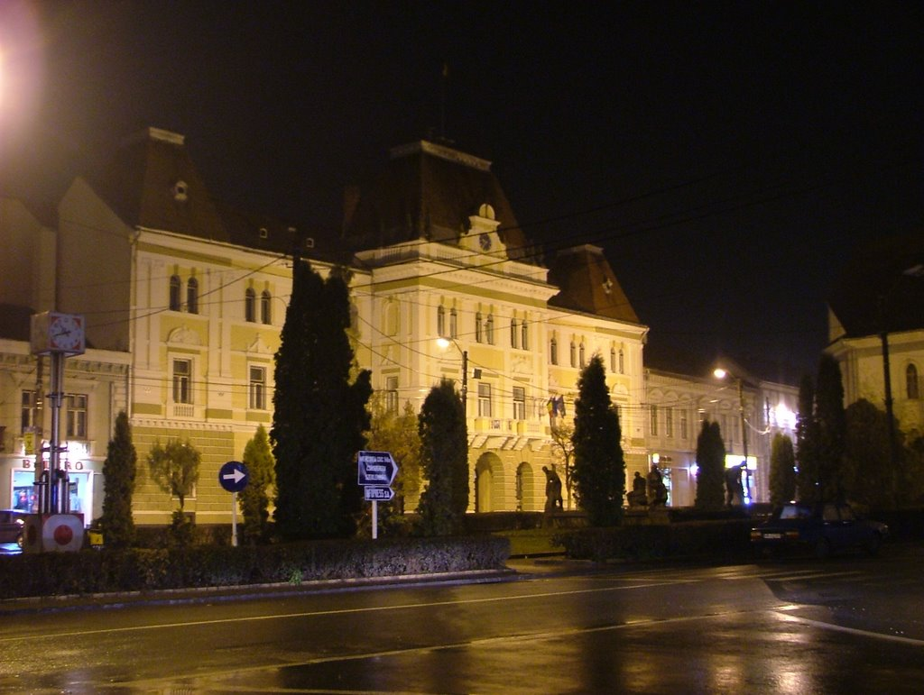

Secretariat:

313 Splaiul Unirii, sector 3, Bucharest, Romania
Phone: +4 021 346.72.31,
Fax: +4 021 346.82.99

REGISTRATION FEES FOR PARTICIPANTS:

100 € until August 15, 2010
110 € after August 15, 2010
50 € for students/ persons accompanying

The registration fee includes the participation in the scientific program, workshop materials, refreshments and meals during the workshop, the banquet and an excursion.

- payment in EUR:
Account: RO25 RNCB 0076 0294 2469 0002

-payment in RON equivalent:
Account: RO52 RNCB 0076 0294 2469 0001

BCR Filiala sector 5
Bd. Tudor Vladimirescu nr. 57,
Sector 5, Bucharest Romania
Ref. “Workshop Fee CEM 2010”

ON-LINE REGISTRATION
will be done on the Workshop site:
http://www.icpe-ca.ro/cem2010 starting from April 15, 2010.

